Website SWOT Analysis Template

# Website SWOT Analysis is a tool that identifies your website’s internal strengths and weaknesses as well as the external opportunities and threats. Understanding these internal and external factors that affect your website is a critical step in determining your overall website strategy.

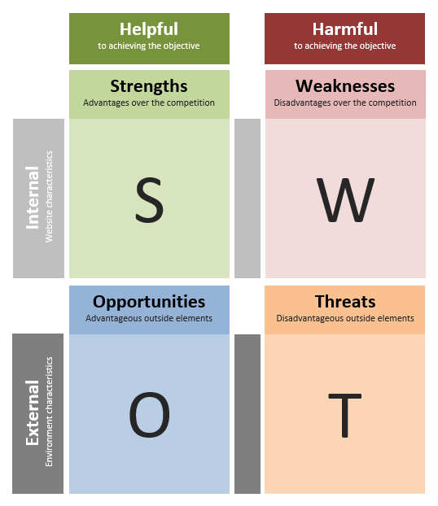SWOT Quadrants

SWOT Analysis is comprised of four quadrants:

**Internal Strengths** – characteristics of your website that give you an advantage and help you reach objectives.

**Internal Weaknesses** – website characteristics that present a disadvantage or prevent you from reaching objectives

**External Opportunities** – elements that the website could use to its advantage to help reach its objectives.

**External Threats** – elements outside of your control that could cause trouble and prevent the website from reaching its business objectives.

Need Help with Website SWOT Analysis?  
Visit: [www.intechnic.com](http://www.intechnic.com) or call +1 (847) 970-6190

SWOT Prerequisites

To prepare to do your website SWOT Analysis, you first need to:

* Define your [SMART Goals](http://resources.intechnic.com/website-goals-worksheet)
* Complete your [Customer Interview Questions Template](http://resources.intechnic.com/customer-interview-questions-template)
* Complete your [Customer Journey Map Template](http://resources.intechnic.com/customer-journey)
* Complete your [Competitive Analysis Worksheet](http://resources.intechnic.com/competitor-analysis-worksheet)

These resources will give you the information you need to conduct a thorough SWOT Analysis.

How to Conduct a Website SWOT Analysis

To complete your SWOT Analysis, you will need to determine how the Strengths, Weaknesses, Opportunities and Threats uncovered in your customer interviews and online competitive analysis will help or prevent you from achieving your business goals. First, you should identify the positive and negative factors affecting your website, and then you should classify these factors as either internal or external.

We’ll walk through all of these steps in the following pages.

Step 1: Identify Internal Attributes of Your Website

Go through the Customer Interview Questions Template, Customer Journey Map Templates and Competitor Analysis Worksheet with green and red markers and mark positive mentions of your website in green and negative in red. Positive attributes are the ones where the website helped customers solve their problems and helped get them to a solution and negative are the ones where something stood in their way. Pay special attention to anything that stands in the way of users completing their goals.

Write the positive and negative findings in the table on the next page. For example: if the competitive analysis shows that your website is *easy to use and navigate* (green), put it in the Strengths column. If a customer mentioned that they *found feature comparison difficult* (red), put it in the Weaknesses column. Note: at this point you are focusing on **your website only** (disregard any external factors).

More Examples:

|  |  |
| --- | --- |
| Strengths | Weaknesses |
| * *The website is user-centric, helping them with their research and decision making by giving them the info they need.* | * *The website is company-centric and doesn’t show unique value to users researching and comparing solutions.* |
| * *The website makes the company look credible, authentic and trustworthy.* | * *The website makes the company look amateurish and not credible.* |
| * *Users find website messages compelling and they can relate to them.* | * *Users find website messages confusing and they don’t relate to them.* |
| * *Users find the information on the site helpful to their decision process.* | * *Users feel the website lacks information they are looking for.* |
| * *The website is easy to use on mobile devices.* | * *The website is not mobile-friendly.* |
| * *The website is quick to load.* | * *The website is frustratingly slow to load.* |
| * *Users find the website in search engines when researching solutions.* | * *The website doesn’t come up in search engines under users’ keywords* |

Internal Attributes of Your Website:

|  |  |
| --- | --- |
| Strengths | Weaknesses |
|  |  |

Step 2: Identify External Factors Affecting Your Website

Go through the Customer Interview findings, Competitive Analysis and Buyer’s Journey one more time with blue and yellow markers. This time look for Opportunities – things that the website could do to help customers reach their objectives and help you reach yours (you especially want to focus on things your competitors don’t do, or do badly). Pay special attention to customer “wishes” and mark those in blue, e.g. *Users want clear feature comparisons (which none of your competitors offer).*

At the same time, look for Threats – elements that are outside of your control that could cause trouble or prevent the website from reaching its business objectives. Mark those in yellow. For example: *Many competitors offer solutions very similar to ours.* Now, put those in the corresponding columns in the table on the next page.

More Examples:

|  |  |
| --- | --- |
| Opportunities | Threats |
| * *Users want to be able to easily compare our solution with alternatives.* | * *There are many competitors that offer solutions very similar to ours.* |
| * *Testimonials from happy customers on social media can be used as social proof.* | * *Our solution has a bad reputation and customers consider alternatives.* |
| * *Competitors seem to be neglecting user experience on their websites.* | * *Many prospects do not understand how our solution can solve their problem.* |
| * *There are new markets that can be tapped into.* | * *The current market for the company is shrinking because of the economy.* |
| * *New marketing automation solutions can better engage our prospects.* | * *There are many new competitors entering the market with lower prices.* |
| * *Our content has been featured in trade publications, giving us a credibility boost.* | * *Competitors may copy our website features and ideas.* |
| * *Public perception is changing.* | * *There are new adverse laws and regulations.* |

External Attributes Affecting Your Website:

|  |  |
| --- | --- |
| Opportunities | Threats |
|  |  |

Step 3: Populate SWOT Quadrants

Now transfer the items from your Strengths, Weaknesses, Opportunities and Threats lists into the appropriate quadrant of the Website SWOT Analysis Template (see below).

There are two completed Website SWOT Analysis examples that you can use as guides: one for a B2B website and one for a B2C website.

**Pro Tips: Do’s & Don’ts**

**Do’s**

* Do thoroughly review all available resources to uncover your Strengths, Weaknesses, Opportunities and Threats.
* Do ask your customer-facing departments (sales, marketing, customer service, etc.) to review your Website SWOT Analysis once you are finished. You want to ensure that you haven’t missed anything.
* Do seek out help from a professional agency if you need help.

**Don’ts**

* Don’t allow this to become a laundry list of every factor that could possibly include on your website. Only focus on those factors that will significantly affect your ability to achieve your business goals.
* Don’t let this be the last time you conduct a Website SWOT Analysis! You should review this document periodically, especially when your market changes, your company targets new audiences or after you make significant changes to your website.

# Website SWOT Analysis – Examples of Attributes

**Harmful**to achieving the objective

**Helpful**to achieving the objective

**External** Environment characteristics

**Internal** Website characteristics

**Threats**Disadvantageous outside elements

**Opportunities**Advantageous outside elements

**Weaknesses**Disadvantages over the competition

**Strengths**Advantages over the competition

• Users want to be able to easily compare our solution with alternatives.

• Testimonials from happy customers on social media can be used as social proof.

• Competitors seem to be neglecting user experience on their websites.

• There are new markets that can be tapped into.

• New marketing automation solutions can better engage our prospects.

• Our content has been featured in trade publications, giving a credibility boost.

• Public perception is changing.

• There are many competitors that offer solutions very similar to ours.

• Our solution has a bad reputation and customers consider alternatives.

• Many prospects do not understand how our solution can solve their problem.

• The current market for the company is shrinking because of the economy.

• There are many new competitors entering the market with lower prices.

• Competitors may copy our website features and ideas.

• There are new adverse laws and regulations.

• The website is company-centric and doesn’t show unique value to users researching and comparing solutions.

• The website makes the company look amateurish and not credible.

• Users find website messages confusing and they don’t relate to them.

• Users feel the website lacks information they are looking for.

• The website is not mobile-friendly.

• The website is frustratingly slow to load.

• The website doesn’t come up in search engines under users’ keywords

• The website is user-centric, helping them with their research and decision making by giving them the info they need.

• The website makes the company look credible, authentic and trustworthy.

• Users find website messages compelling and they can relate to them.

• Users find the information on the site helpful to their decision process.

• The website is easy to use on mobile devices.

• The website is quick to load.

• Users find the website in search engines when researching solutions.

# Website SWOT Analysis – B2C Example

**Harmful**to achieving the objective

**Helpful**to achieving the objective

**External** Environment characteristics

**Internal** Website characteristics

**Threats**Disadvantageous outside elements

**Opportunities**Advantageous outside elements

**Weaknesses**Disadvantages over the competition

**Strengths**Advantages over the competition

* New marketing automation solutions can better engage our prospects.
* There are new markets that can be tapped into.
* The current market for the company is shrinking because of the economy.
* There are many new competitors entering the market with lower prices.
* Users feel the website lacks information they are looking for.
* The website is frustratingly slow to load.
* The website is not mobile-friendly.
* Users find website messages compelling and they can relate to them.
* The website makes the company look credible, authentic and trustworthy.
* Users find the website in search engines when researching solutions.

# Website SWOT Analysis – B2B Example

**Harmful**to achieving the objective

**Helpful**to achieving the objective

**External** Environment characteristics

**Internal** Website characteristics

**Threats**Disadvantageous outside elements

**Opportunities**Advantageous outside elements

**Weaknesses**Disadvantages over the competition

**Strengths**Advantages over the competition

* Users want to be able to easily compare our solution with alternatives.
* Testimonials from happy customers on social media can be used as social proof.
* There are many new competitors entering the market with lower prices.
* Many prospects do not understand how the solution can solve their problem.
* The website is company-centric and doesn’t show unique value to users researching and comparing solutions.
* Users find website messages confusing and they don’t relate to them.
* The website makes the company look credible, authentic and trustworthy.
* The website is quick to load.
* The website is easy to use on mobile devices.

# Your Website SWOT Analysis

**Harmful**to achieving the objective

**Helpful**to achieving the objective

**External** Environment characteristics

**Internal** Website characteristics

**Threats**Disadvantageous outside elements

**Opportunities**Advantageous outside elements

**Weaknesses**Disadvantages over the competition

**Strengths**Advantages over the competition

* Item 1
* Item 2
* Item 3
* Item 1
* Item 2
* Item 3
* Item 1
* Item 2
* Item 3
* Item 1
* Item 2
* Item 3